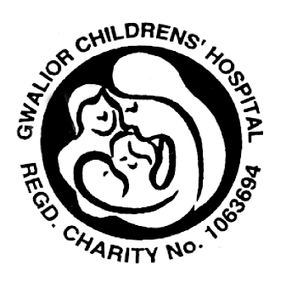

Gwalior Children’s Hospital Regd. Charity No. 1063694

Working to help and provide for poor, disabled and destitute children,
and their families in the poverty stricken city of Gwalior and its surrounding
Chambal region in India through Gwalior Hospital for children and women,
General Hospital, Eye Centre, Rural Health Centres and Mobile Hospital,
School and Orphanages, Hospice for children with HIV and terminal illnesses
It’s all helping…can you?

For any enquiries contact charity at address at the end of this form or phone 01922 629842.

Sponsor Form/ Fund Raising Event form

Name

Event Date

I consent that all proceeds will go to the above named charity

Signed Date

Name | Address & Email Address | Amount |   Please sign and  tick if you are a tax payer and permit the charity to  reclaim tax on your donation
PLEASE CONTINUE OVERLEAF…

Name | Address & Email Address | Amount | Please sign and  tick if you are a tax payer and permit the charity to reclaim tax on your donation
All forms, donations & cheques payable to GWALIOR CHILDREN’S HOSPITAL CHARITY

14 Magdalene Road Walsall West Midlands WS1 3TA
Tel: 01922629842 (UK) Fax: 01922632942 (UK) Email: gwalior.hospital@care4free.net
www.gwalior.hospital.care4free.net www.helpchildrenofindia.org

