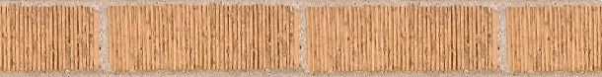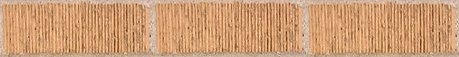 Please send your donations by cheque made to “Gwalior Childrens Hospital Charity-buy a brick appeal” to Gwalior Childrens Hospital, 14, Magdalene Road, Walsall. WS1 3TA (U.K.) or you can donate on line through credit or debit or CAF cards now. Visit www.gwalior.hospital.care4free.net

BUY A BRICK
For The Orphanage

“SNEHALAYA – the home with love”

BUY A BRICK

FOR The ORPHANAGE
“SNEHALAYA – the home with love”

Please send your donations by cheque made to “Gwalior Childrens Hospital Charity-buy a brick appeal” to Gwalior Childrens Hospital, 14, Magdalene Road, Walsall. WS1 3TA (U.K.) or you can donate on line through credit or debit or CAF cards now. Visit www.gwalior.hospital.care4free.net

